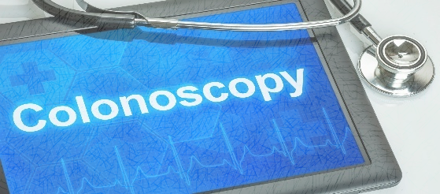

GoLytely Prep Instructions
Name: _____________________________________ Date: ________________________________________

Doctor: ____________________________________ Check-In Time: ________ Procedure Time: __________

*Failure to comply with these instructions may result in a cancellation of your procedure.
** You will need to purchase one (1) box of Dulcolax Laxative tablets at any drugstore or Walmart. You will be given a prescription for the GoLytely to take to your pharmacy, or the prescription will be sent to your pharmacy for you to pick up.
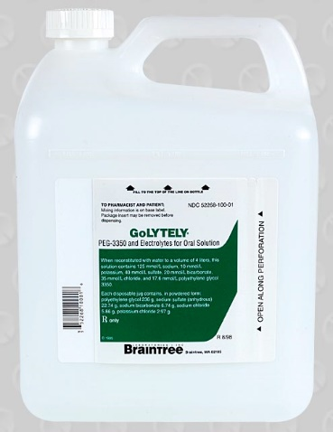
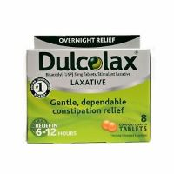

Instructions for Prep
- If you take any NSAIDs (ex., Ibuprofen, Aleve, Naproxen) or blood thinners such as Coumadin, Plavix, Pradaxa, Xarelto, Cilostazol, Aggrenox, Eliquis, ask your physician for additional instructions for possibly stopping medications before the colonoscopy procedure.
- Two days before the procedure: No fiber, No raw fruits or vegetables, No salads or nuts.
- Day before the procedure:
- Clear liquids only. NO solid foods. NO milk or milk products. NO red or purple drinks or Jell-O. NO vegetable juice or juice with pulp.
- Examples of clear liquids- Water, Gatorade, Powerade, Apple juice, White grape juice, Tea, Soft drinks, Jell-O, popsicles, black coffee (may add sugar or sweetener), bouillon cubes dissolved in water, Lemonade, and Crystal light.
- At 8:00 am, take four (4) Dulcolax laxative tablets.
- At 10:00 am, mix one (1) gallon of GoLytley with your choice of clear liquid. Start drinking the liquid throughout the day. You will need to complete the one-gallon mixture by 8:00 pm.
- Nothing to eat or drink after midnight.

Day of procedure
- You will be sedated for the test and MUST have someone drive you home. If no one accompanies you as your driver, the procedure cannot be performed and will be rescheduled. Your driver must remain on the premises during your procedure. Public transportation (taxi, bus, uber driver, etc.) cannot be used.

- If you take blood pressure, thyroid, seizure, or diabetic medication, please take it with only a small sip of water the morning of your procedure.

- You are not permitted to drive, drink alcohol, operate machinery, or sign any legal documents the entire day of your test due to the sedation you will receive.

- Do NOT use smokeless tobacco, chew gum, or have any mints/candy the morning of your procedure

- Do NOT wear any jewelry or bring any valuables.

- You are not permitted to drive, drink alcohol, operate machinery, or sign any legal documents the entire day of your test due to the sedation you will receive.

- Plan to be at the facility for about 2-3 hours, depending on the preparation, procedure, and recovery time. Plan on taking the entire day off work, school, etc.

- Please provide 72-hour notice if you wish to cancel or reschedule your procedure to avoid a cancellation fee.

- **If you take OZEMPIC/SEMAGLUTIDE or any other GLP-1 receptor agonists, you must hold the medication 7 (seven) DAYS before your scheduled procedure. If you are taking this medication to manage your diabetes, you may want to consult with your prescribing physician. Please note that you are at risk of having your procedure canceled if you have not held this medication.

- If you have questions about your procedure instructions, don’t hesitate to call the number below to speak with your physician’s nurse.
Dr. Angtuaco- 501-406-9291 Dr. Coppola- 501-406-9301 Dr. Coggins- 501-406-9337
Dr. Hughes- 501-406-9311 Dr. S. Jones- 501-406-9321 Dr. J. Jones- 501-406-9302
Dr. McElreath- 501-406-9331 Dr. Patel- 501-406-9341 Dr. Svoboda- 501-406-9351

SURGERY CENTER
10915 N. Rodney Parham
Little Rock, AR 72212

Phone: 501-747-2828

